# AWS EC2 Instance Deployment Guide

Comprehensive Deployment with Commands, Screenshots, and Key Points

Created by: Samith R Gowda

Date: July 4, 2025

## Table of Contents

1. 1. Introduction
2. 2. Key Points
3. 3. Step-by-Step Deployment Process
4. 4. Screenshots Walkthrough
5. 5. Conclusion

## 1. Introduction

## This document outlines the complete process for deploying an AWS EC2 instance, configuring it with Ubuntu, installing Node.js and related packages, and running a live server application. It also includes the global installation and configuration of Redis for caching and MongoDB for NoSQL database support. Additionally, the guide covers how to host a React frontend application on the same EC2 server. Screenshots and key terminal commands are included to support practical understanding and real-world deployment

## 2. Key Points

* Use AWS Free Tier (t2.micro) for cost-effective deployment.
* Choose Ubuntu Server for compatibility with Node.js.
* Create and securely store your key pair (.pem file).
* Install Node.js, npm, and PM2 to manage the app process.
* Use Git to clone the repository and deploy the application.
* Monitor app status using PM2.
* Install MongoDB globally for scalable NoSQL database support.
* Install Redis globally to enable high-speed in-memory caching

## 3. Step-by-Step Deployment Process

AWS EC2 Instance Deployment Guide

Step 1: Login to AWS Console

Login to your AWS account and navigate to EC2 Dashboard.

Step 2: Launch Instance

Click on 'Launch Instance' to start the configuration.

Step 3: Choose Instance Type

Select an instance type (e.g., t2.micro) for free tier usage.

Step 4: Configure Key Pair

Create or instance Name to access the instance securely.

Step 5: Choose ubuntu Server

Choose Ubuntu .

Step 6: Add Storage

Specify storage volume size and type as required.

Step 7: Create Key pair

Generate key pair for PEM & PPk file.

Step 8: Configure Security Group

Choose Key pair type RSA, and Private key file format .pem file.

Step 9: Review and Launch

Choose Storage for instance settings and click on 'Launch Instance'.

Step 10: Instance Launch Confirmation

Confirmation page shows successful launch and instance ID.

Step 11: Go to Instance Dashboard

Navigate to EC2 > Instances to monitor the instance status.

Step 12: Copy Public IP

Copy the instance's public IP address to connect via SSH.

Step 13: Connect via SSH

Use terminal or SSH client: `ssh -i keypair.pem ec2-user@<Public-IP>`.

Step 14: Update && Upgrade version

Run: `sudo apt update -y && sudo apt upgrade -y`.

Step 15: Install Nodejs

Run: `sudo apt-get install -y nodejs`.

Step 16: Global Installation Npm Packages

Run: `sudo apt install npm`

Step 17: Check Versions

Run: `node -v npm -v` Check Node version && NPM version.

Step 18: Pm2 Global Installation

Run:`Run command for pm2 global installation`.

Step 19: Select Repo Link

Select your repository link

Step 20: Clone Project

Run the following command your Repository link.

Step 21: Install Packages

Step 22: Run your project

Run: npm install for package installation. && start your server

Step 23: Pm2 List

Review your project list for (pm2 list, pm2 save).

## Step 24: Global Installation of AWS EC2 Instance with Redis Setup

Installed an AWS EC@ instance globally and configured it with Redis for high-performance in -memory data storage

## Step 25: Verifying Redis Service Status on AWS EC2

I checked the status of the Redis service on my AWS EC2 instance to ensure it was running correctly and ready to handle requests.

Step 26: Global Installation of MongoDB on AWS EC2 Server

I installed MongoDB globally on my AWS EC2 server to enable robust and scalable NoSQL database support for my application

## 4. Screenshots Walkthrough

The following section includes deployment steps along with screenshots to visually guide you through each stage. Ensure each image corresponds with the mentioned command or action.

## 5. Conclusion

By following the steps outlined in this guide, you should be able to successfully deploy an EC2 instance, configure the environment with Node.js, and launch your web application. This guide serves as a reliable resource for beginners and intermediate users deploying cloud-based Node.js apps using AWS. Additionally, Redis and MongoDB were globally installed to support in-memory caching and NoSQL database functionalities, ensuring high performance and scalable data management for modern web applications.

# EC2 Instance Deployment Guide

## Step 1: Login to AWS Console

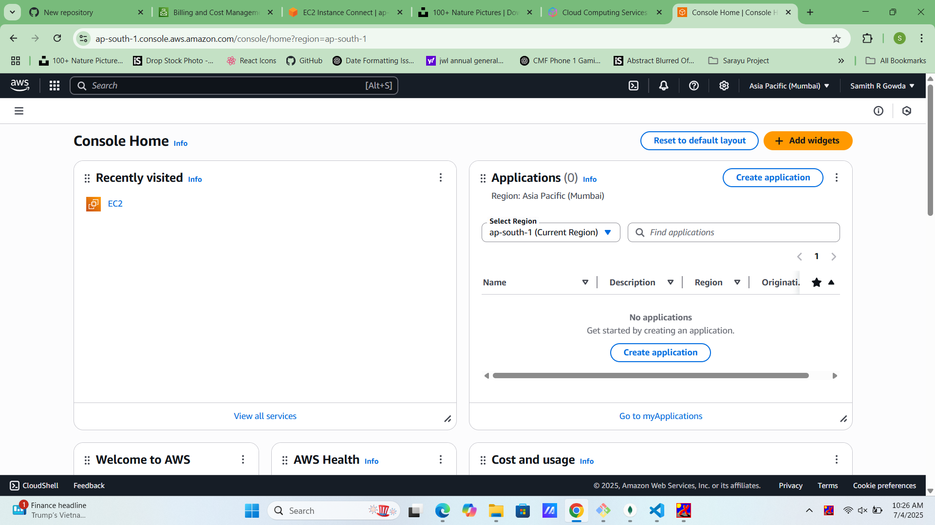Login to your AWS account and navigate to EC2 Dashboard.

## Step 2: Launch Instance

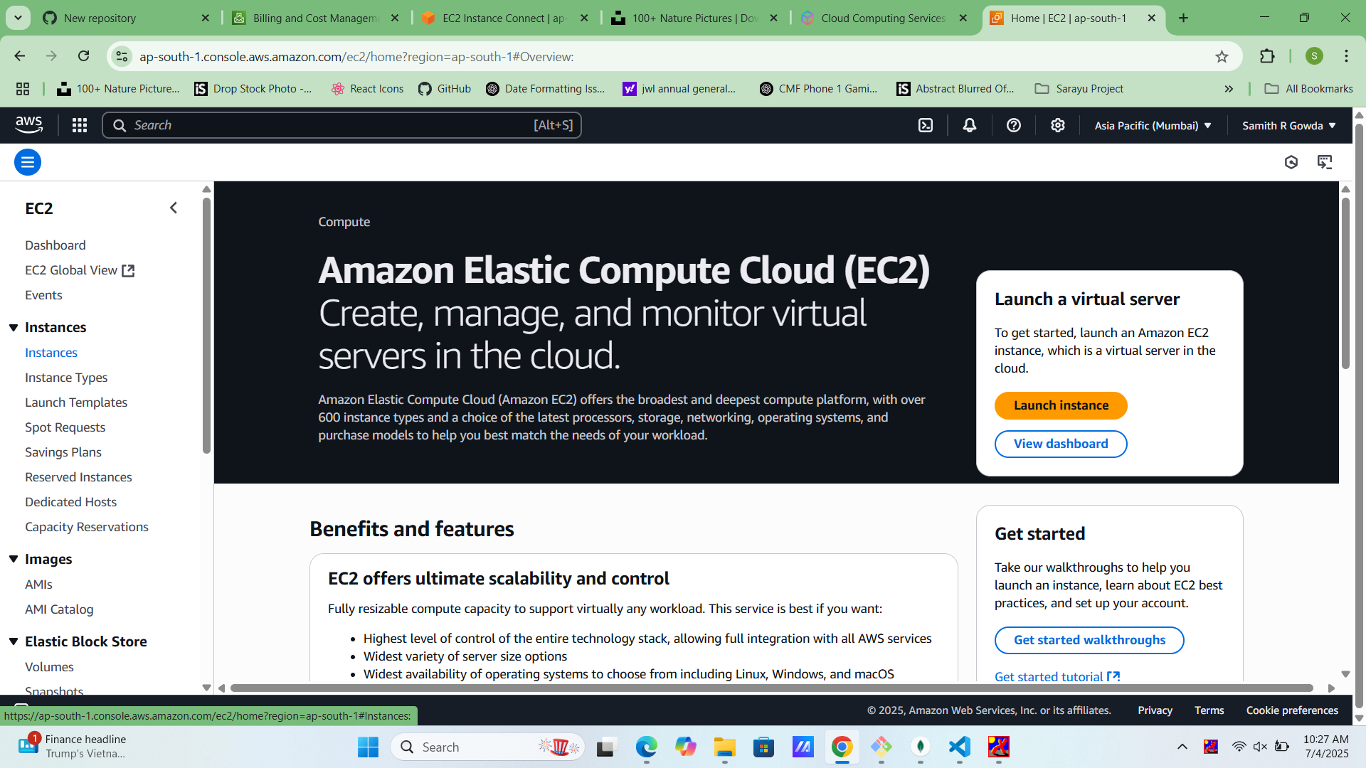

Click on 'Launch Instance' to start the configuration.

Step 3: Choose Instance Type

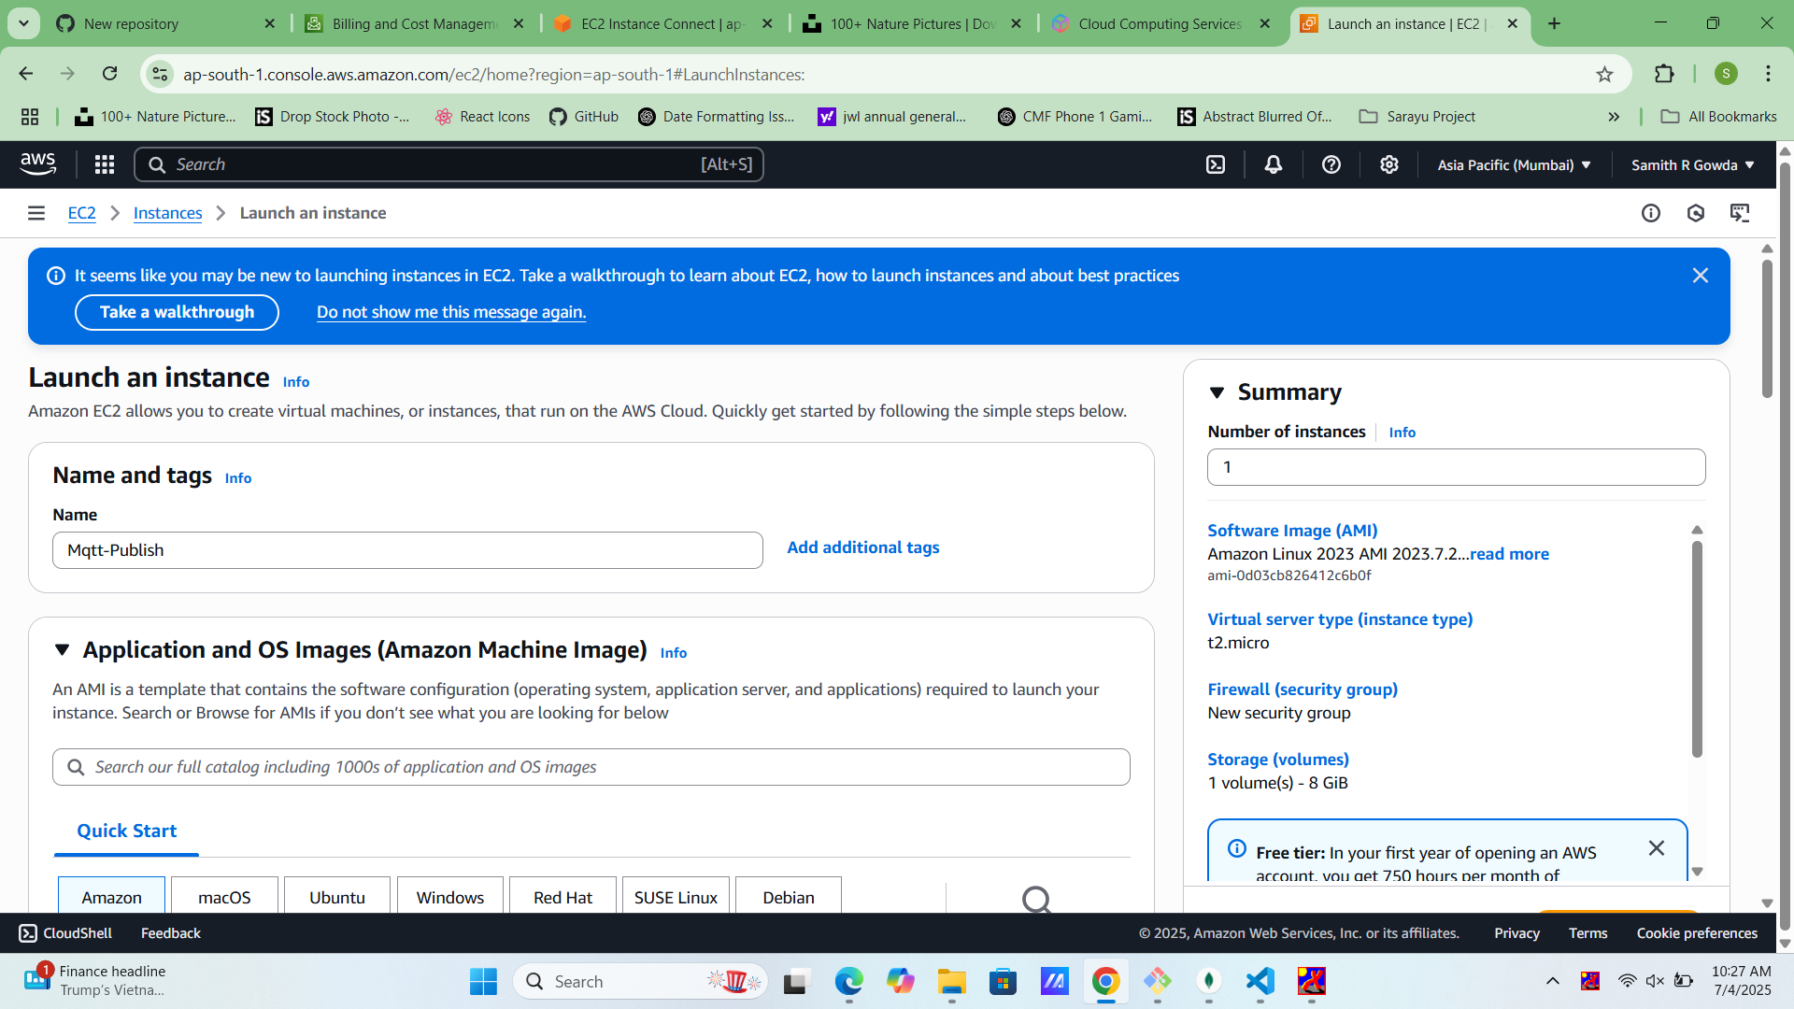Select an instance type (e.g., t2.micro) for free tier usage.

## Step 4: Configure Key Pair

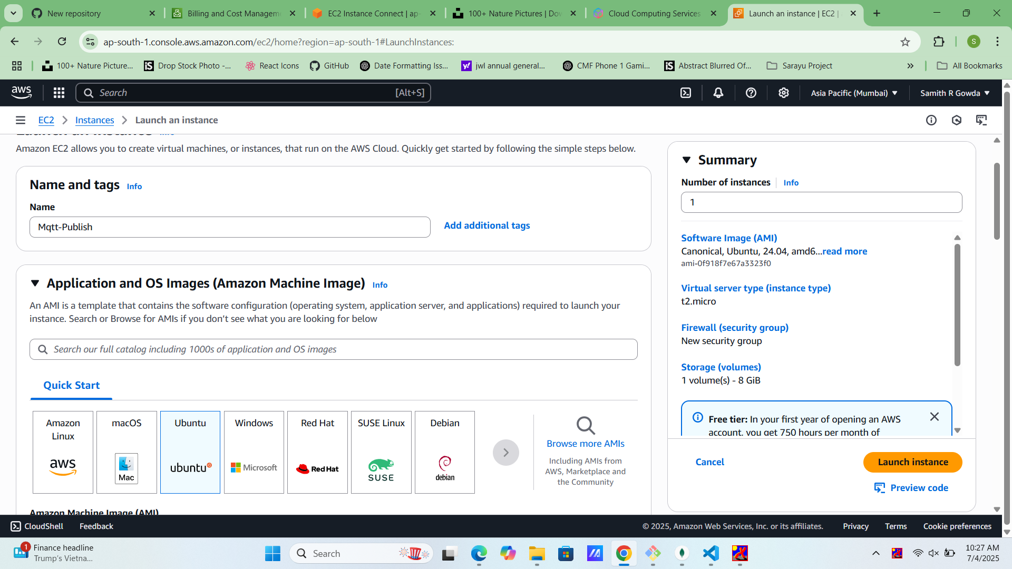

Create or instance Name to access the instance securely.

Step 5: Choose ubuntu Server

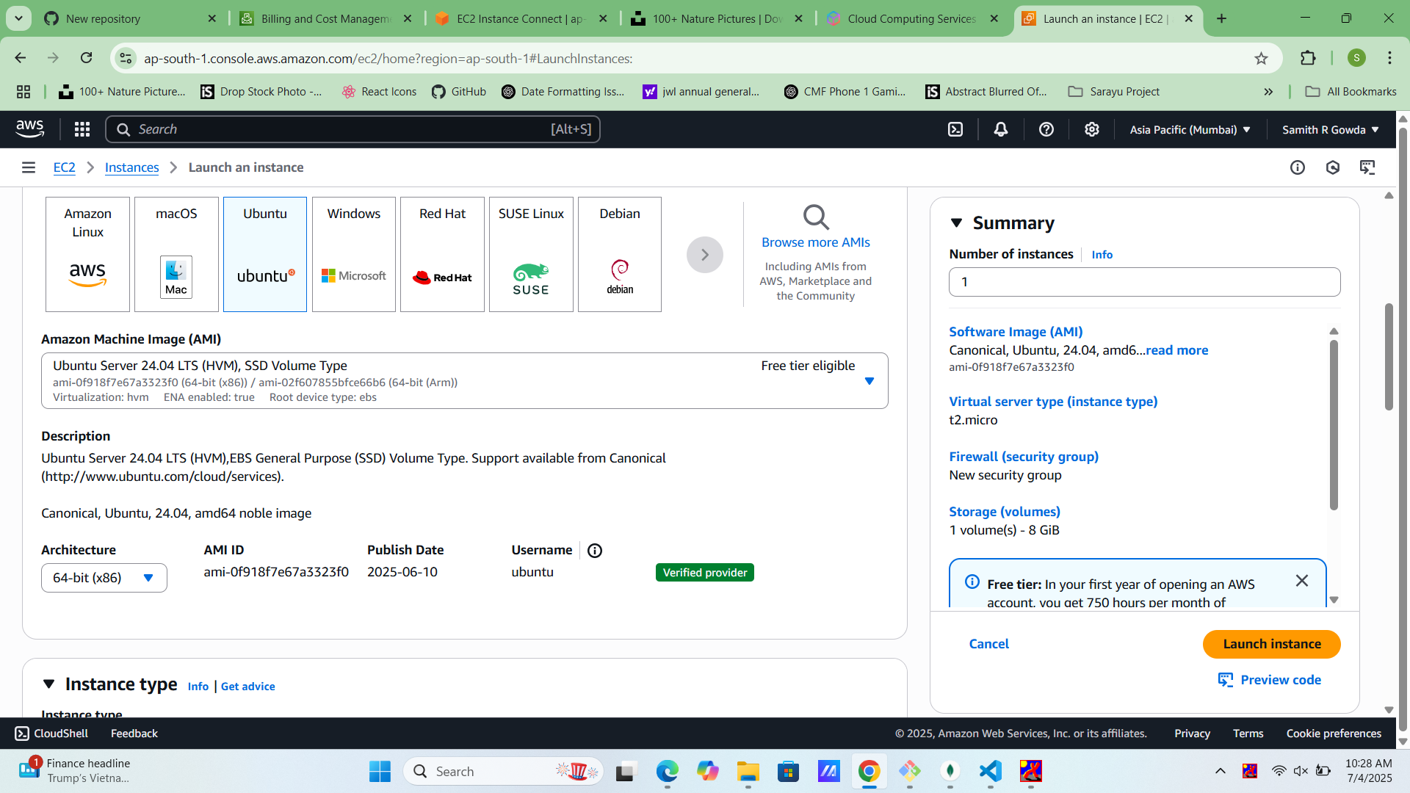Choose Ubuntu .

## Step 6: Add Storage

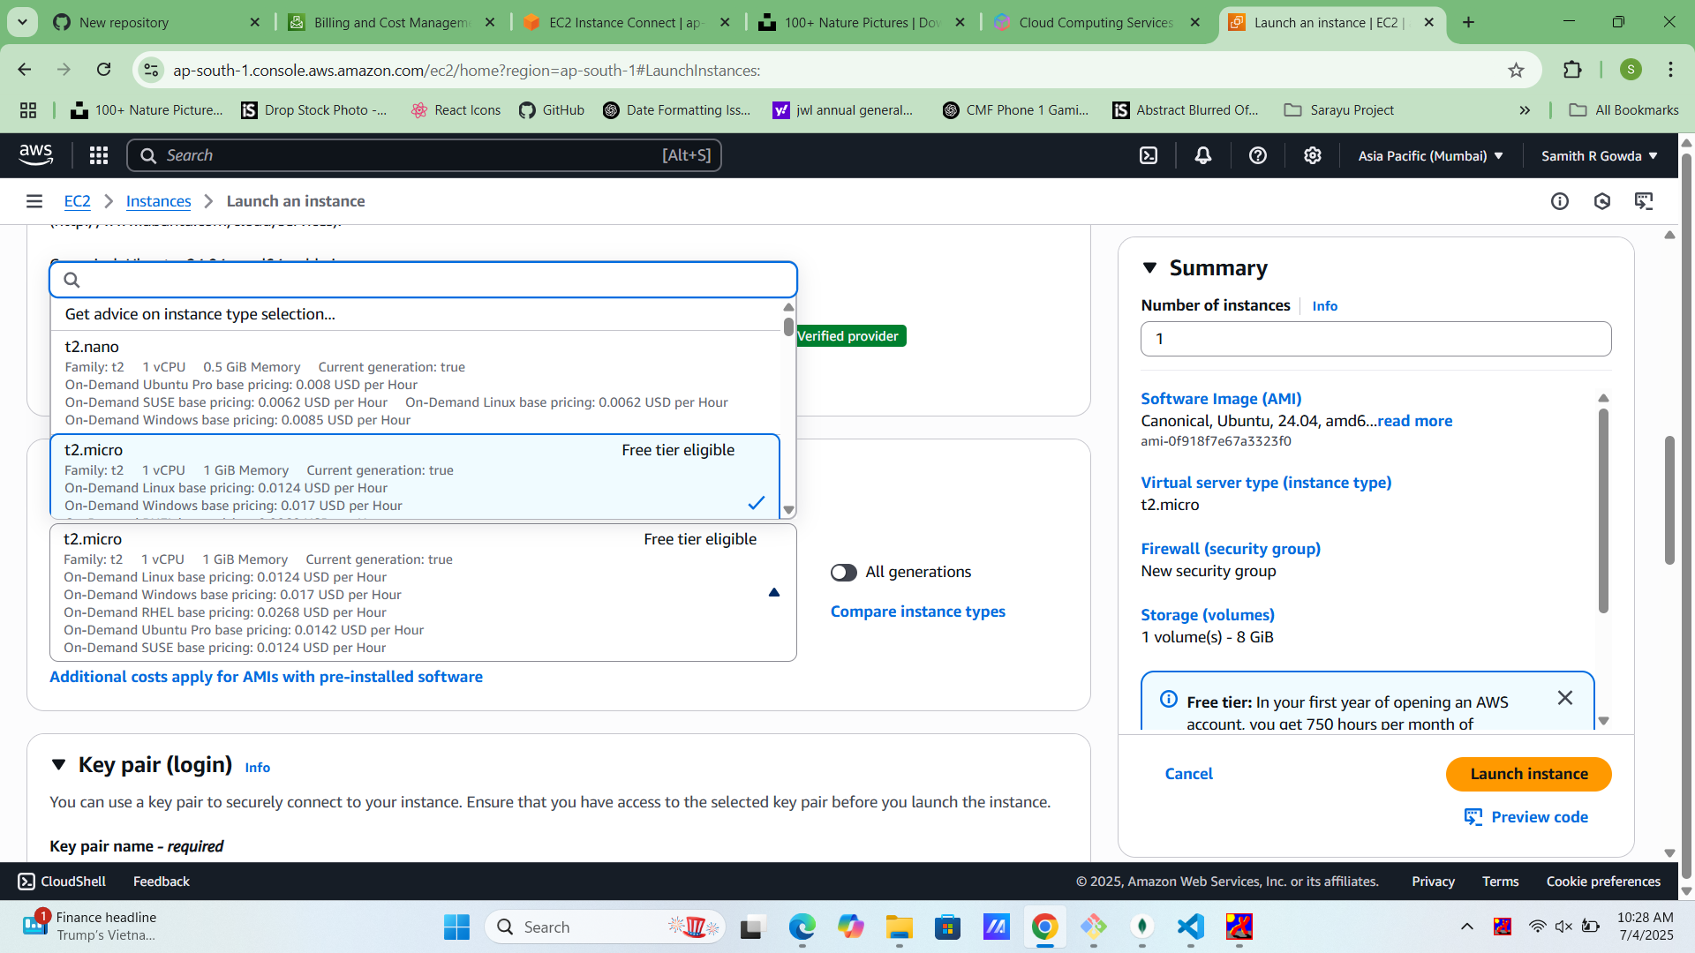Specify storage volume size and type as required.

## Step 7: Create Key pair

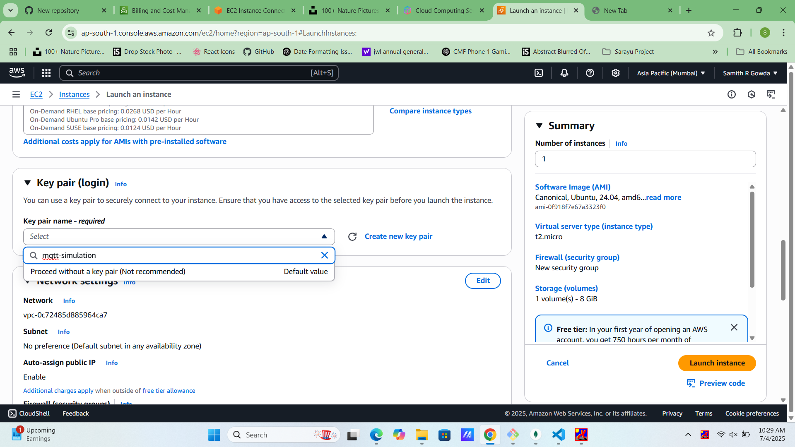Generate key pair for PEM & PPk file.

## Step 8: Configure Security Group

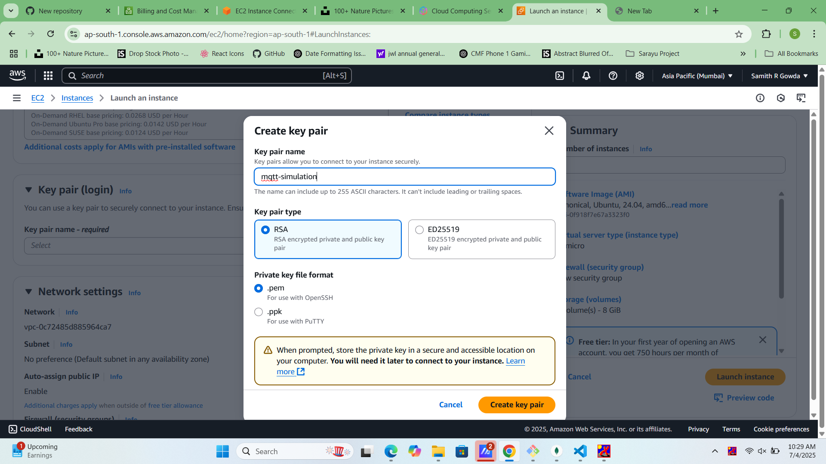Choose Key pair type RSA, and Private key file format .pem file.

Step 9: Review and Launch

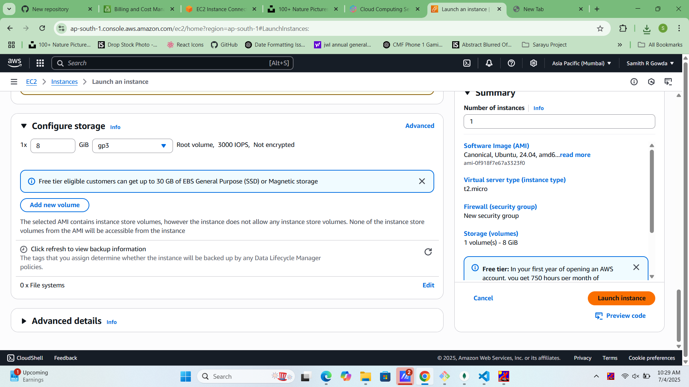

Choose Storage for instance settings and click on 'Launch Instance'.

## Step 10: Instance Launch Confirmation

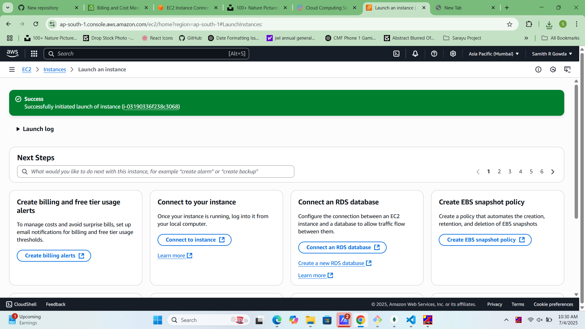

Confirmation page shows successful launch and instance ID.

## Step 11: Go to Instance Dashboard

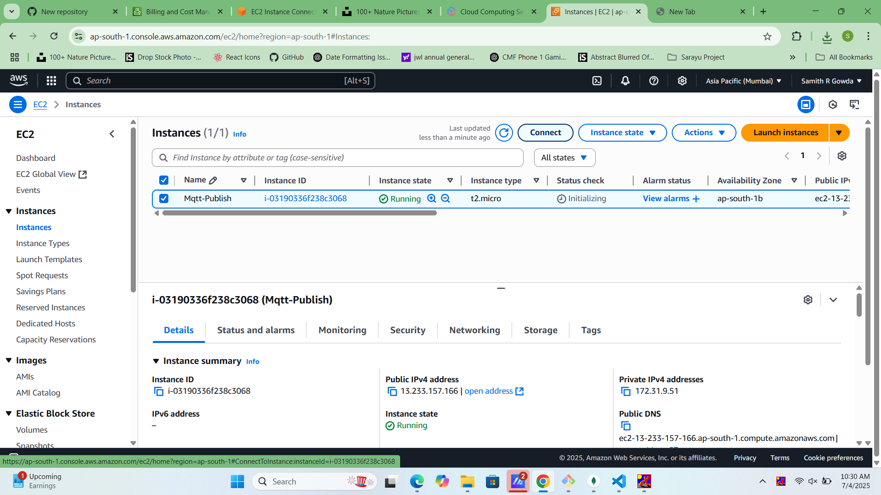Navigate to EC2 > Instances to monitor the instance status.

## Step 12: Copy Public IP

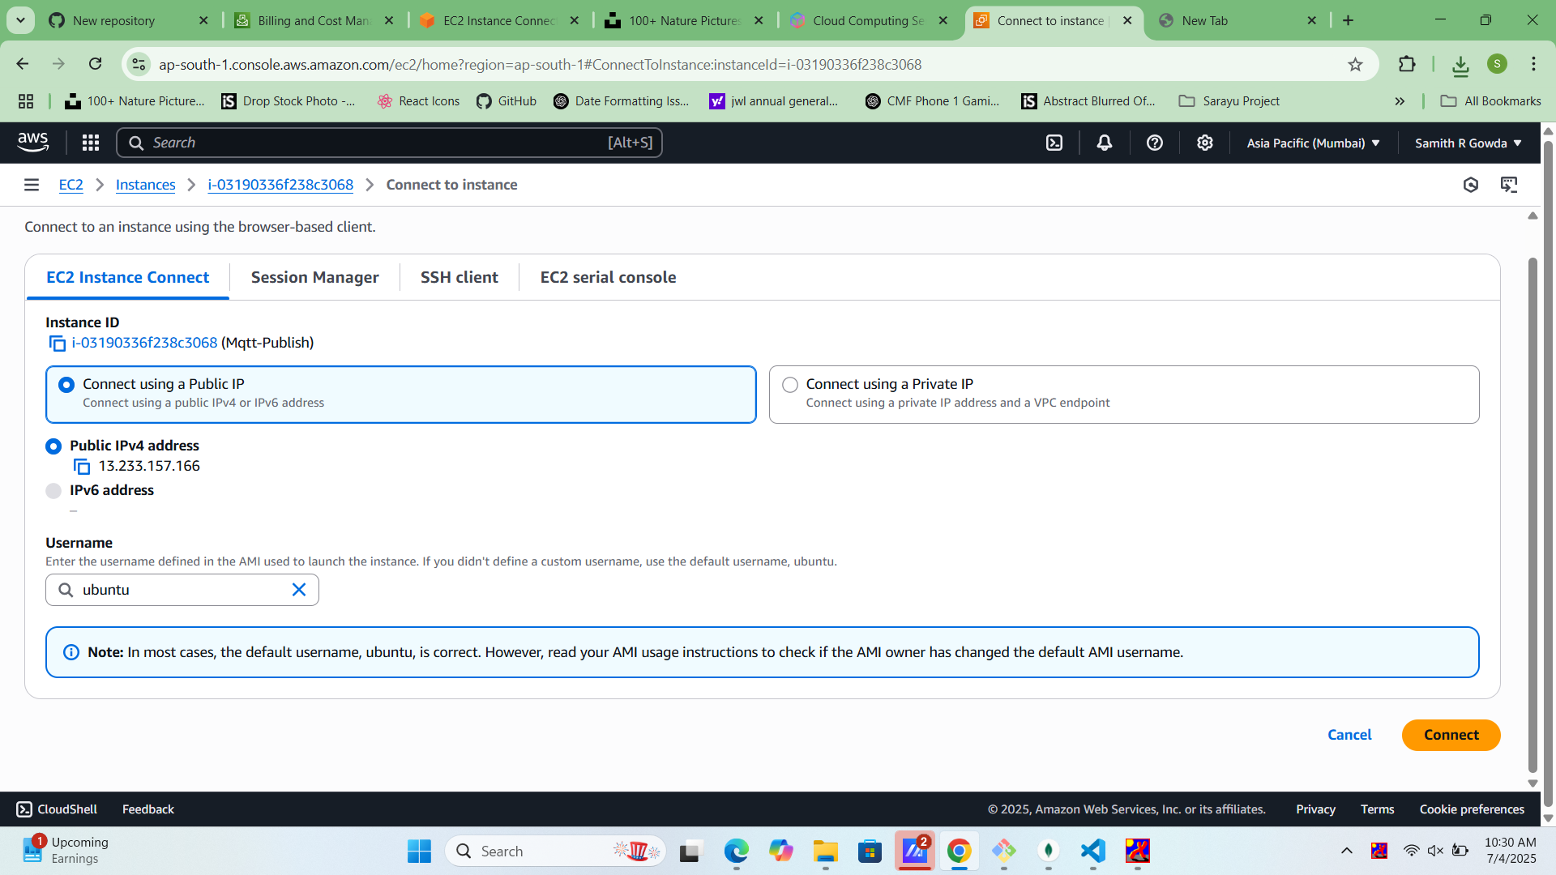

Copy the instance's public IP address to connect via SSH.

## Step 13: Connect via SSH

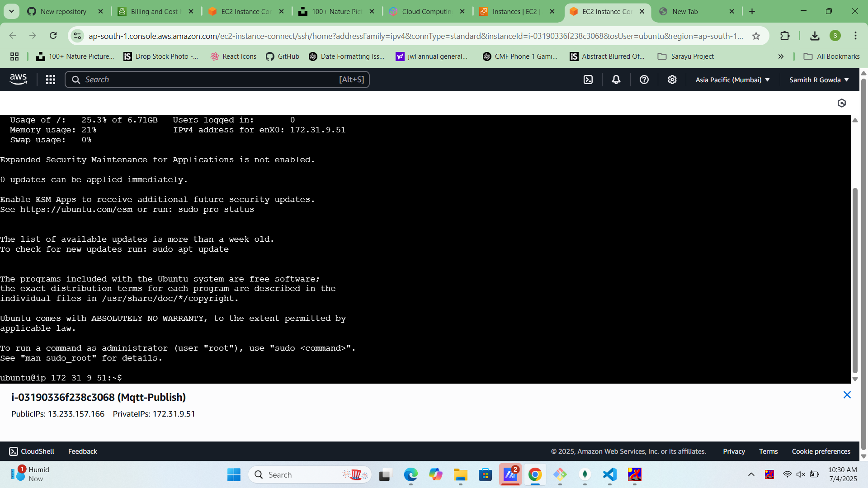

Use terminal or SSH client: `ssh -i keypair.pem ec2-user@<Public-IP>`.

## Step 14: Update && Upgrade version

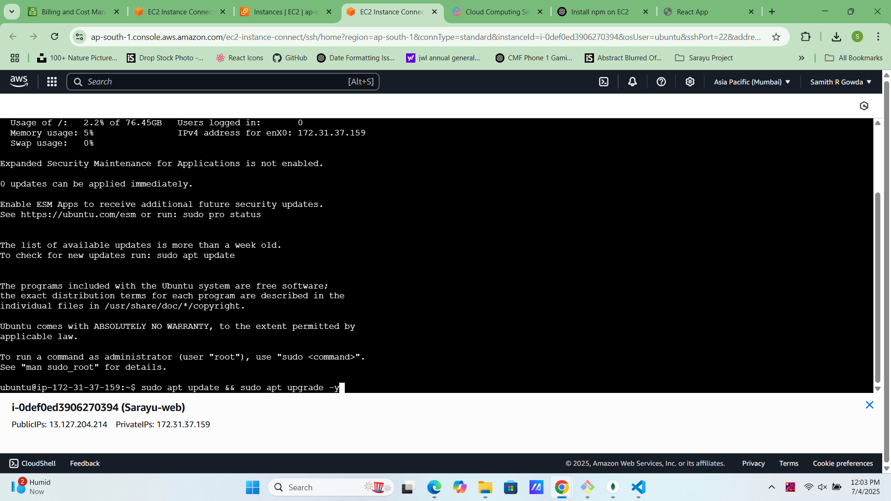

Run: `sudo apt update -y && sudo apt upgrade -y`.

## Step 15: Install Nodejs

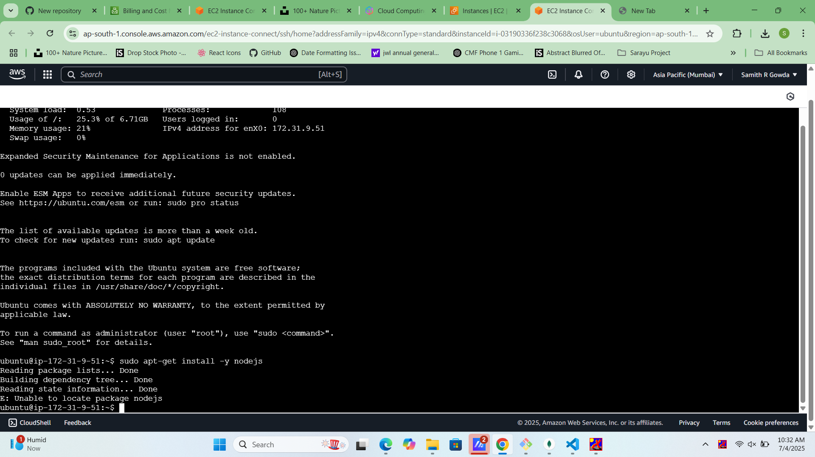

Run: `sudo apt-get install -y nodejs`.

## Step 16: Global Installation Npm Packages

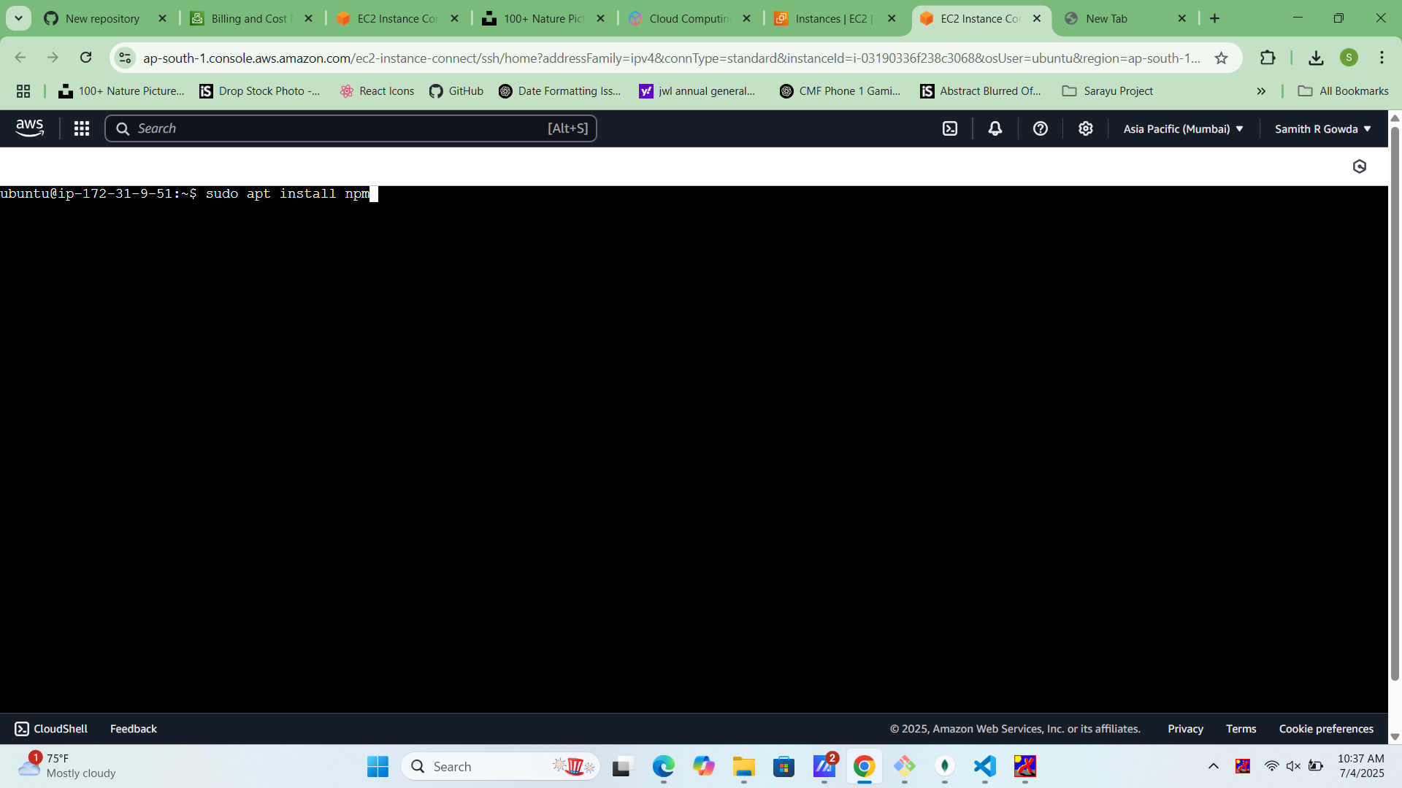

Run: `sudo apt install npm`

## Step 17: Check Versions

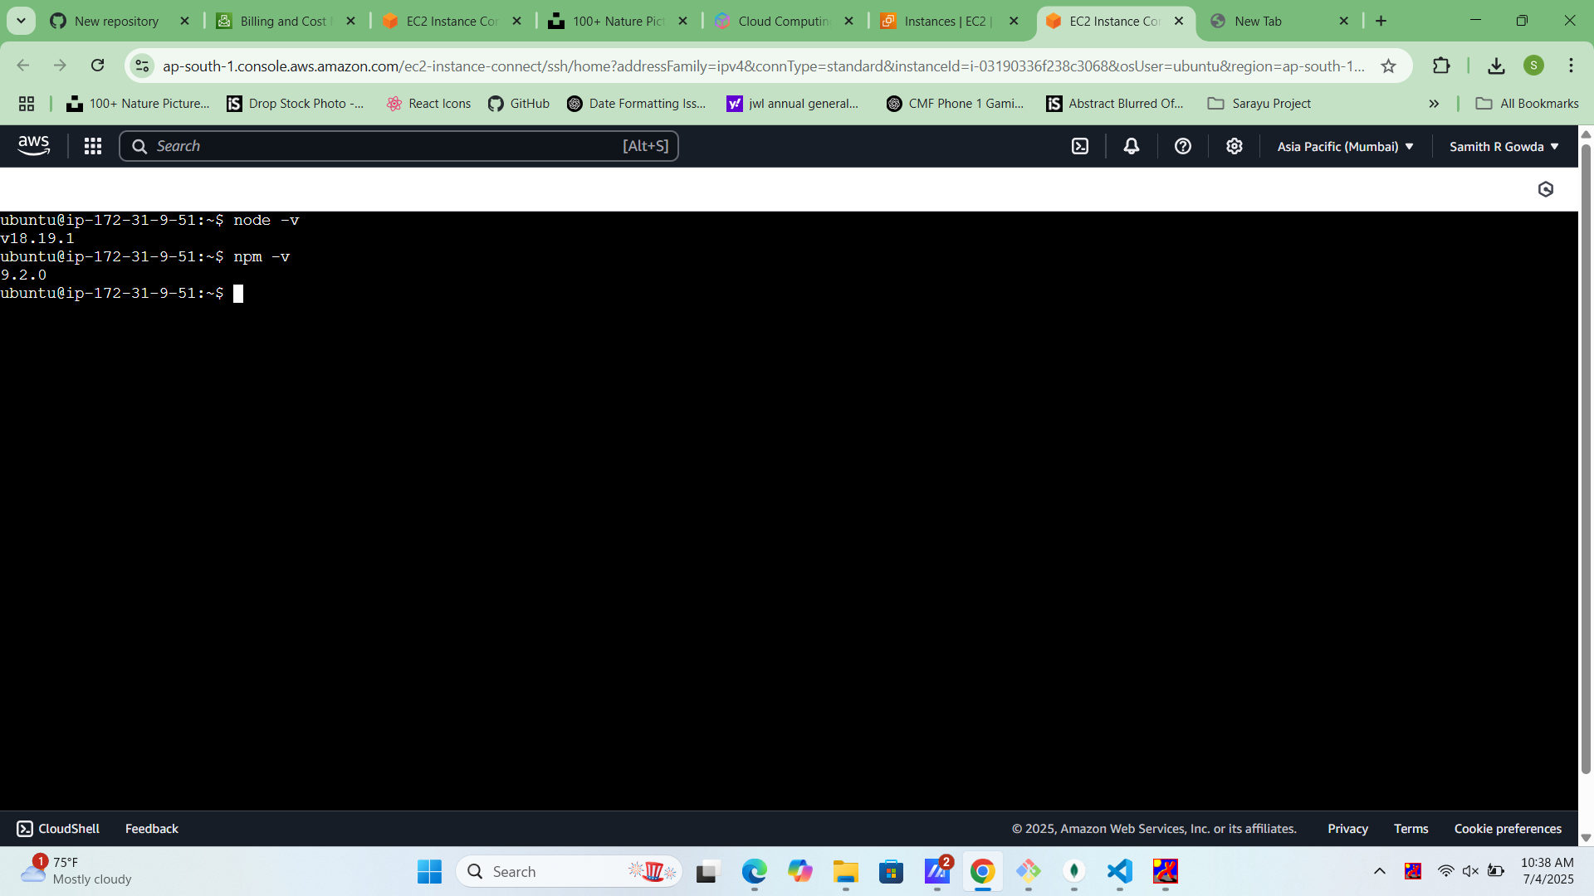

Run: `node -v npm -v` Check Node version && NPM version.

## Step 18: Pm2 Global Installation

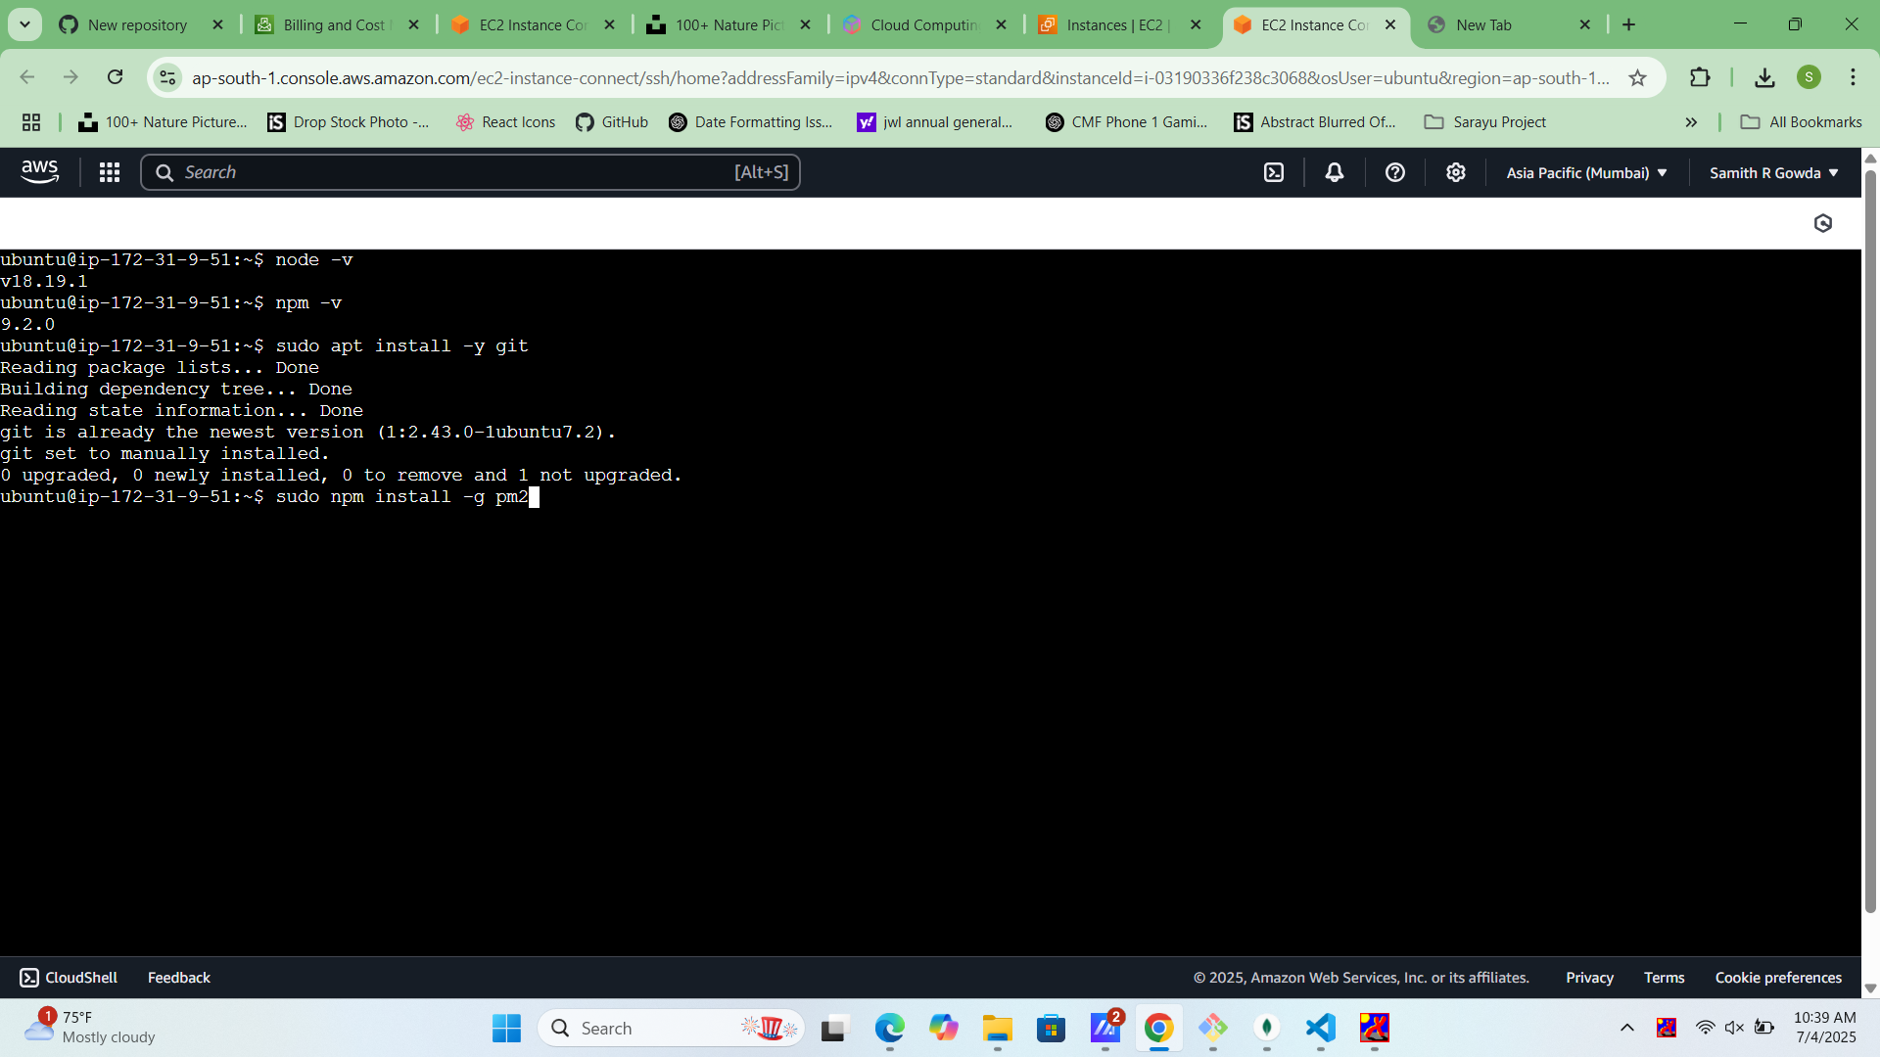

Run:`Run command for pm2 global installation`.

## Step 19: Select Repo Link

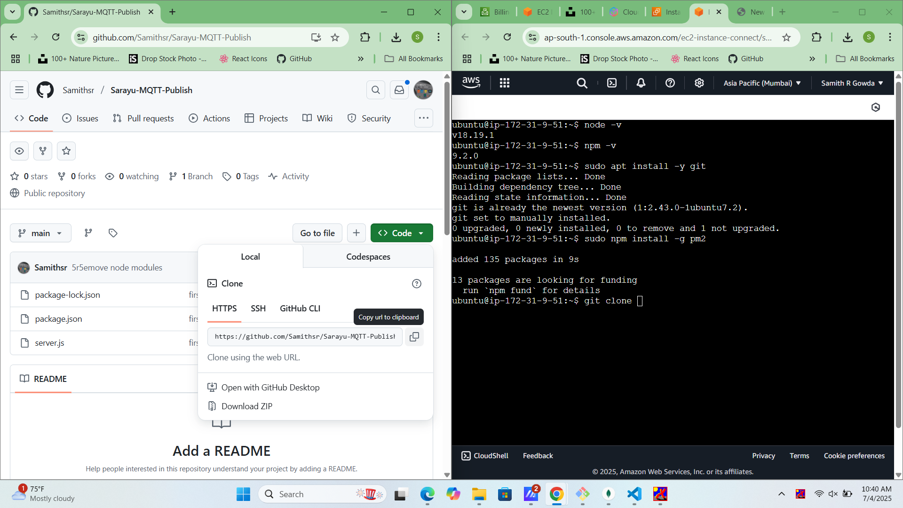

Select your repository link

## Step 20: Clone Project

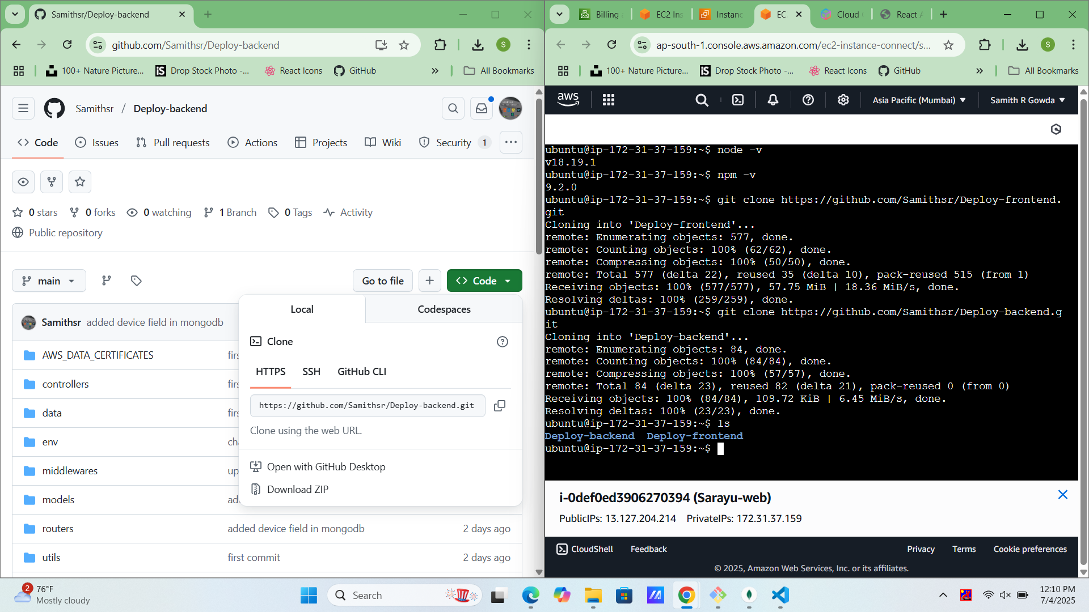

Run the following command your Repository link.

## Step 21: Install Packages

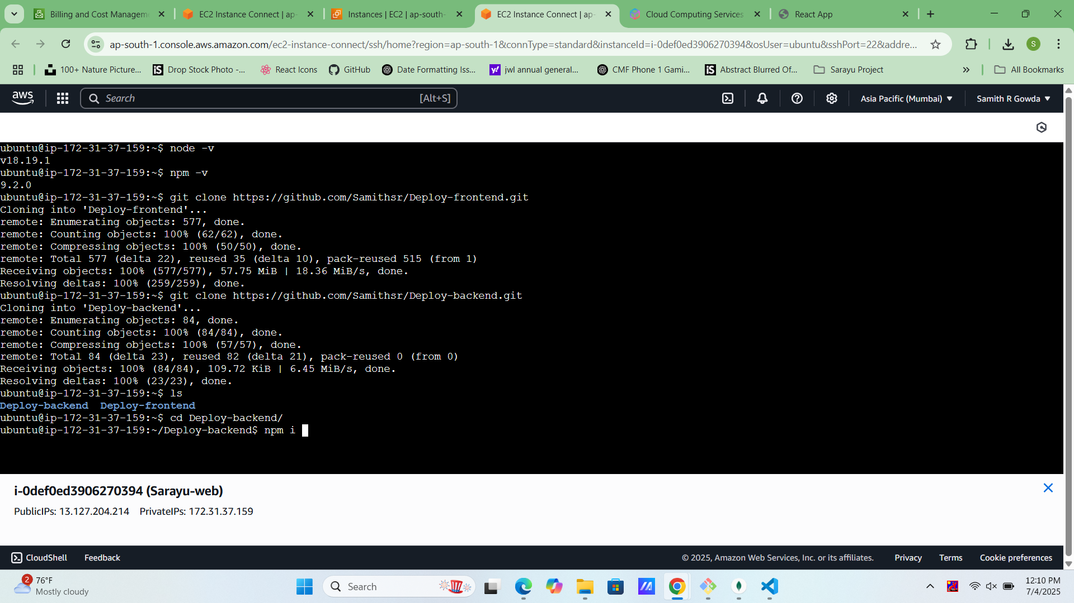

Install Node Packages inside Project file.

## Step 22: Run your project

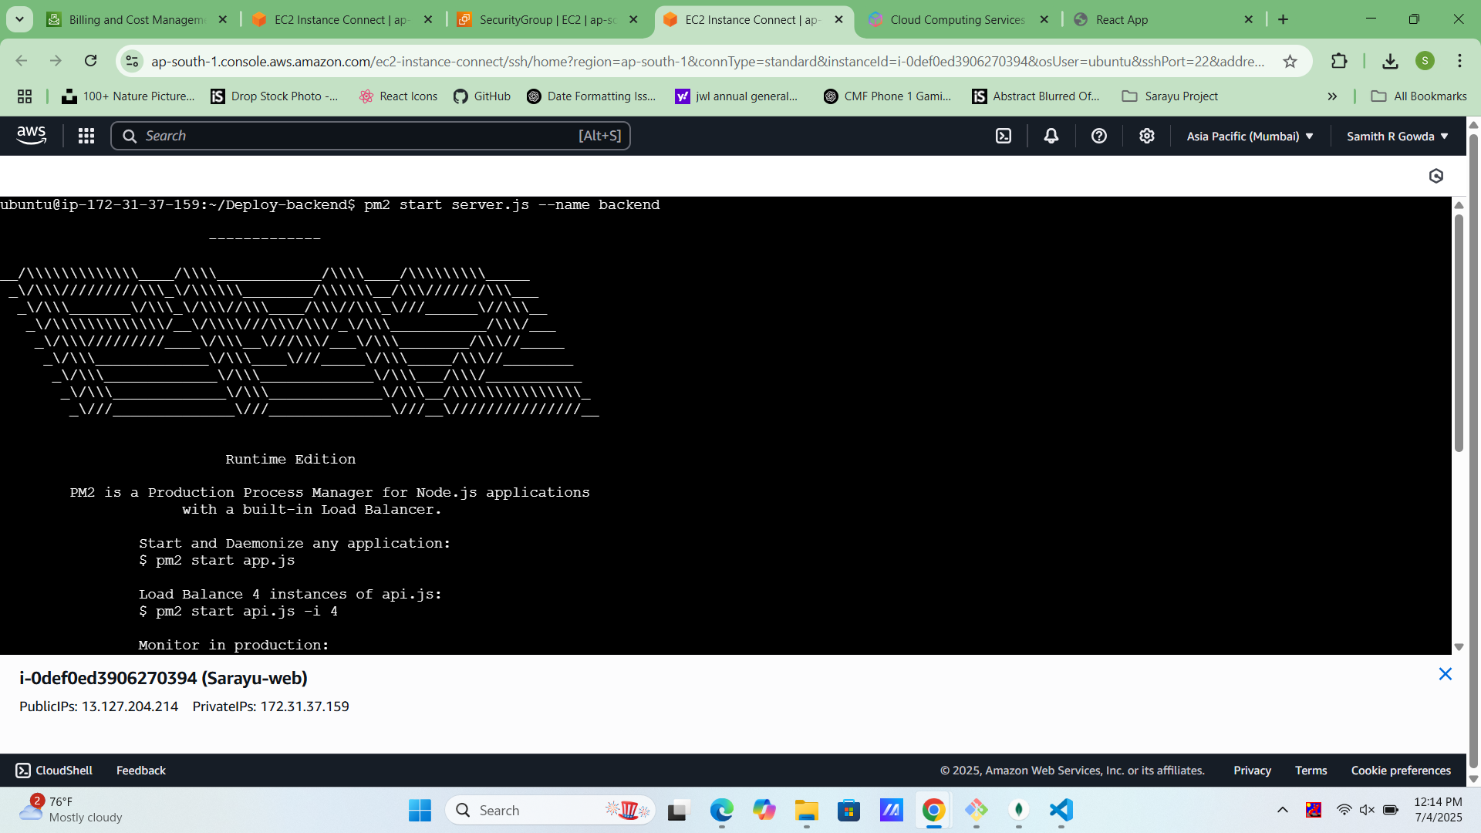

Run: npm install for package installation. && start your server

## Step 23: Pm2 List Pm2 save

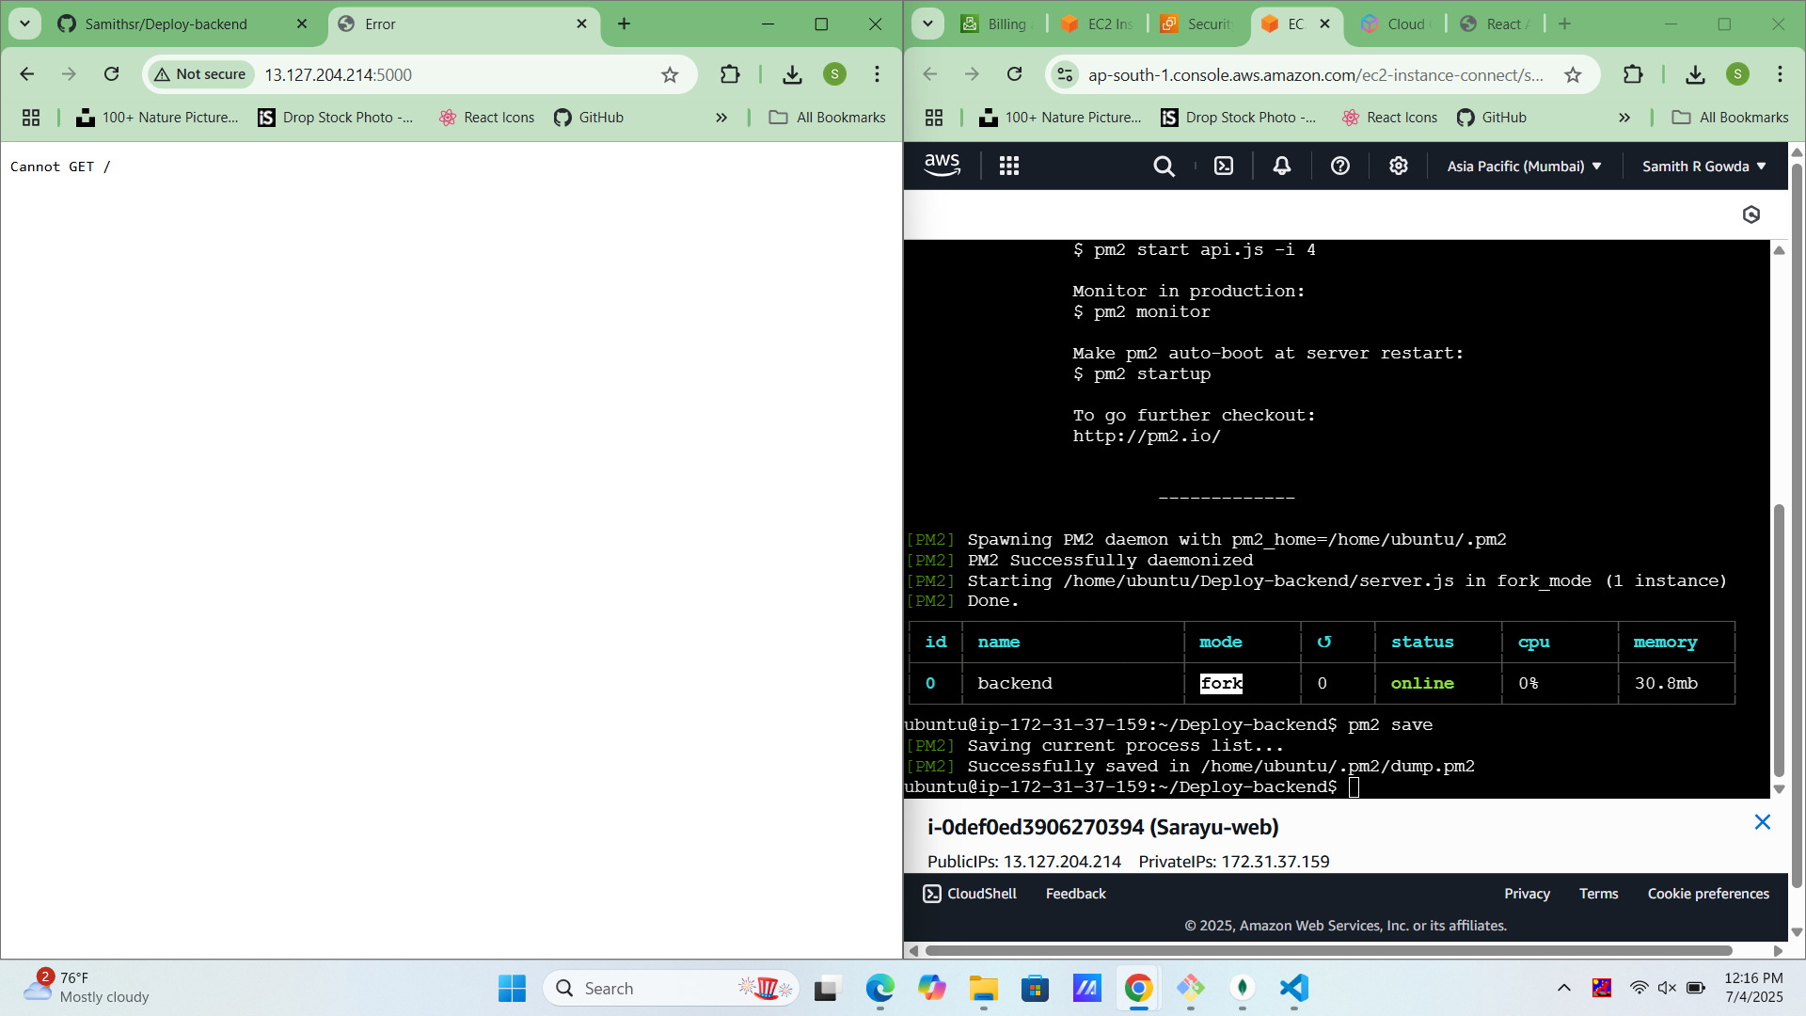

Review your project list for (pm2 list) && pm2 save.

## Step 24: Global Installation of AWS EC2 Instance with Redis Setup

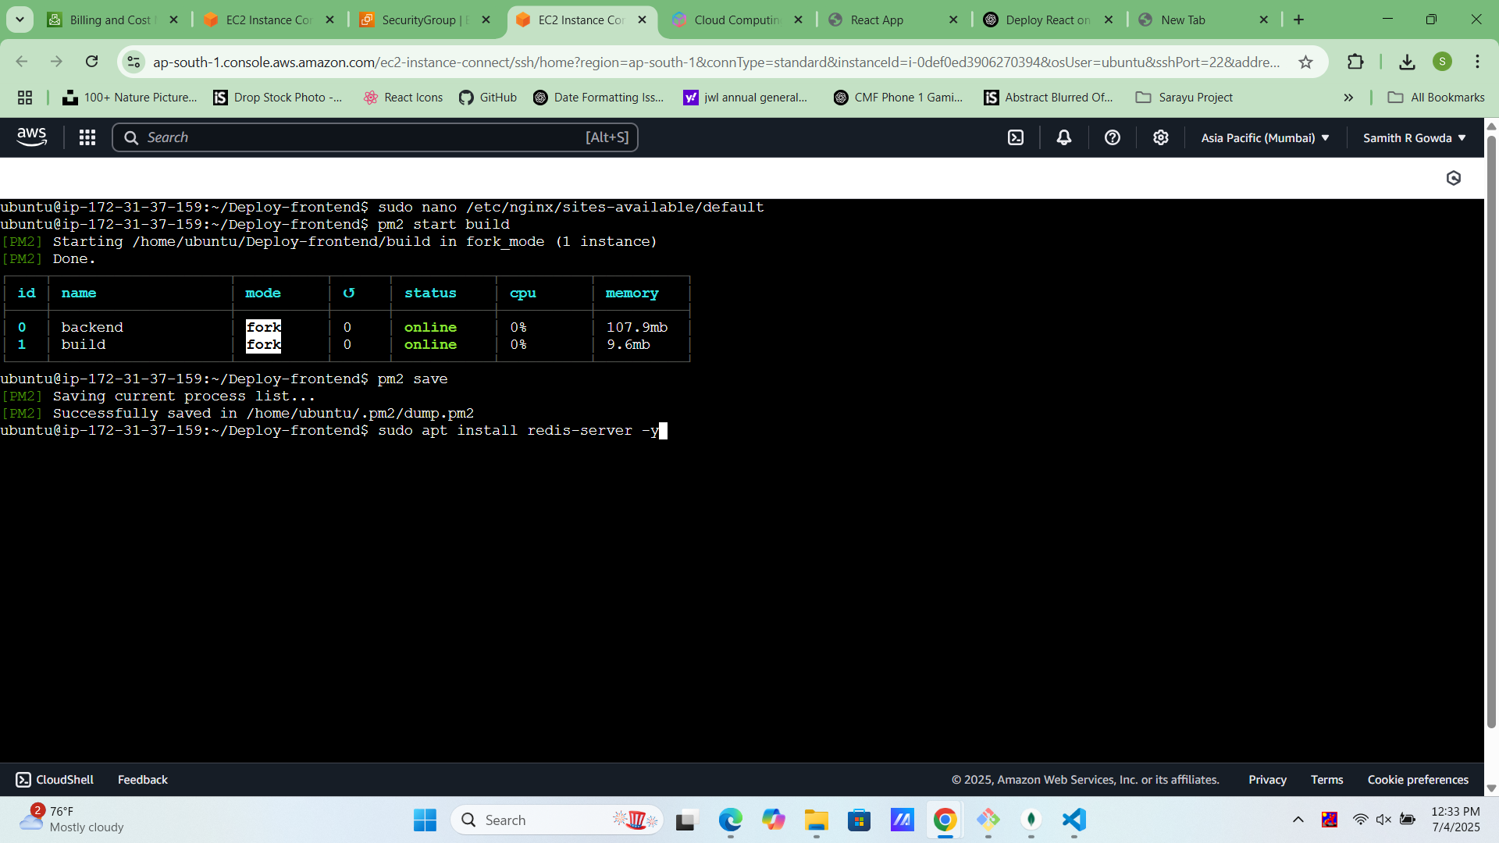

Run Redis Server command Globally.

## Step 25: Check Redis status

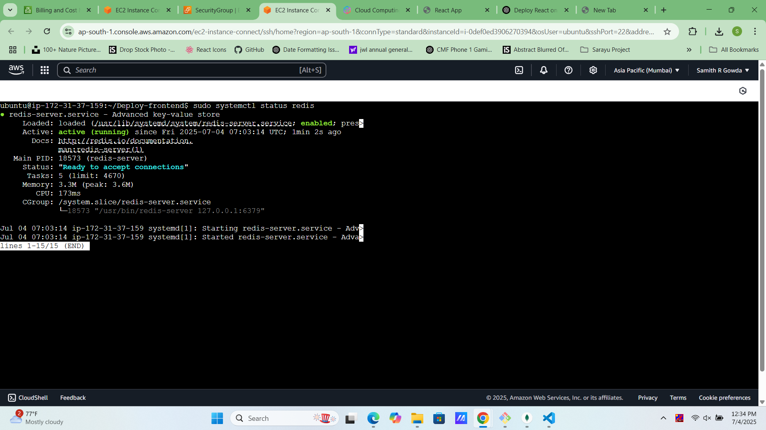

I checked the status of the Redis service on my AWS EC2 instance to ensure it was running correctly and ready to handle requests.

## Step 26: Global Installation of MongoDB on AWS EC2 Server

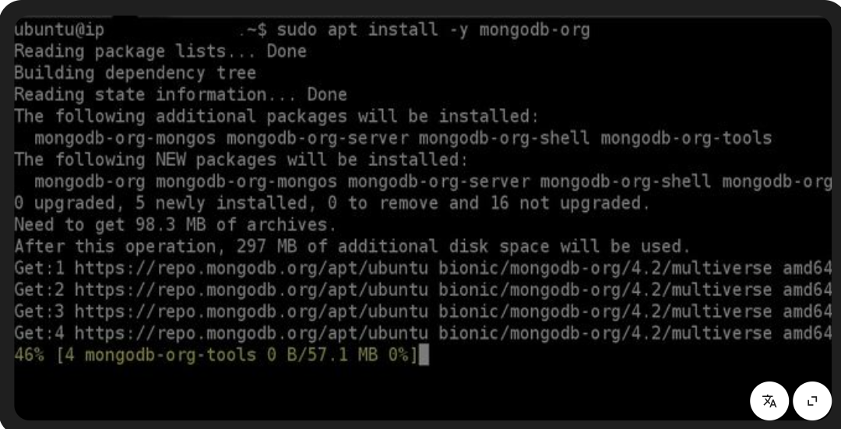

I installed MongoDB globally on my AWS EC2 server to enable robust and scalable NoSQL database support for my application..